Improving Manufacturing Cycle Time % Attainment with Real Time Dispatching

Thangappan Krisnamuthi

Application Center of Excellence (ACE)
Email: t-krisnamuthi@ti.com
Texas Instruments Malaysia
No 1, Lorong Enggang 33, 54200 Ampang, Selangor

Abstract

Integrated Circuits (IC) probing has recently become a focal point of attention and investment for Texas Instruments Inc. This is due to high equipment cost and limited capacity which have rendered the probe stage of IC manufacturing as a bottleneck.

In order to improve cycle time attainment at Probing process a method is needed to reduce cycle time variation between multiple product groups by having prompt execution of product. Thus a dispatching system was introduced to achieve this goal.

This paper describes the benefit achieved by implementing and effectively and efficiently using an Advanced Real Time Manufacturing Dispatching system in Texas Instruments Inc Clark Philippines Probe Operations. More precisely, Probing operations cycle time percent attainment was increased and the variation of cycle times between different types of product was decreased. Effectively this means our cycle times become more predictable, we can be more confident that more of our product will meet the target cycle time promised to the customer, and less variable among products means we can be consistent with all our customers.

1. 0 Introduction

Most manufacturing facilities have some sort of dispatching system. A dispatching system function is to instruct the factory operator “what is the next Lot” of material that they must process in the machine. Usually a basic dispatching function is included in all Manufacturing Execution Systems (MES). These basic dispatching functions are usually limited in capabilities and very inflexible to be modified without major changes in computer code.

Semiconductor fabrication, assembly and test sites are highly and much more complex requiring advanced dispatchers capable to recognize and match many different attributes from the products against the equipment capabilities. Advanced dispatchers are also able to perform this matching on real time and they are very flexible to allow business logic modification in very short time by personnel without a computer science degree.

We implemented our real time dispatching solution using a commercial software tool called APF RTD. This tool is powerful and very flexible as we require it to be but of course it does not come with the business logic to achieve the cycle time and operations output objectives. Therefore it is also essential to have the know-how in operations management to achieve these objectives and put this know how in the business logic of RTD.

1.1 Real-Time Dispatch (RTD)
Real-Time Dispatching is a software component that executes advanced dispatching algorithms based on real-time Computer Integrated Manufacturing data. This component is tightly integrated with Manufacturing Execution Systems (MES) to provide advanced shop floor control of production material. Its main purpose is to increase production efficiencies by providing a tactical execution of operational concepts.
The Real Time Dispatcher software can access the status of the shop floor and execute dispatching rules whenever signaled to do so by the RTD-GUI. This technology enables manufacturing personnel to develop custom rules and operating policies that are specific to their factory.
Rules are infinitely flexible, can contain multiple criteria, and can reference the dynamic state of any entity in the factory. All the criteria your facility uses in the real world, such as setup, priority, complex batching logic, etc., can be incorporated into RTD. Additionally, the rules are computationally efficient, so even the most complex dispatching decisions can be made in a fraction of a second.
Once the dispatch decision has been computed, it is presented to the operator on a fully-integrated dispatch screen through web browser like Internet Explorer or Fire Fox. The operators on the shop floor see the RTD tool as seamlessly integrated with the MES. The implementation of RTD is mainly aimed to make lot dispatching work easy to operator.

2. 0 Problem Statement

Customer expects that we deliver product in the right quantities, on time, and within the shortest possible time. To achieve short target cycle time that would allow to deliver on time and be able to do this evenly to all product sharing resources in a manufacturing line it is essential to:

- Poor communication between line planners, ICS, MH and operators.
b) Inconsistence Probe Output attainment and Lot on time delivery.
c) Poor operation consistency and high variability

Therefore, the problem is how to utilize our human resources and advanced real time dispatching system to keep the WIP at target level, ensure required throughput but most important of all, reduce WIP flow variability. These are the areas where the dispatcher will contribute to achieve target cycle times.

3. 0 Project Detail
3.1 Implementation Methodology
In order to ensure that all the necessary parameters were checked and that the scope of the project was on track, a Task force team was formed. This core team consisted of members from Manufacturing, Product Engineer and Information Technology department both from local, ACE and Global level. The Manufacturing and Product Engineering group could be the key business users and Global team is responsible for project planning and implementation. The Global team consisted of a Business Analysis, Systems Architect, Rule Developer and an Application engineer.
The main objectives of that team were:
- Compile user requirements for a system
- Provide a corporate level suggestion for solutions.
A feasibility study was then performed which analyzed the initial user requirements specific to AT’s IT framework and operational methods. The team then compiled an initial report documenting integration points, business rule proposals, system architecture, a WBS (work breakdown structure), resource needs and allocation, and a detailed project timeline.
A Module approach was used to implement the Global Rule rollout. The Module approach involved selecting only VLCT module in a processing area at a time for implementing the Global Rule. This ensured that proper training and systems testing were in place before any conversion occurs. Exposure is limited and allows for more detailed monitoring and performance tracking.
A major requirement from the Customer was to view a lot list that displays all lots through a friendly GUI. The team gathered the input from the manufacturing representative regarding the GUI configuration and this information was cross checked with historical data, process and product engineering requirements. TI has 2 versions of RTD, one is EBT/SCT and AT version. Initial challenge is to come up with the agreement on which platform to use for Clark Probe.
3.2 Project Approach Analysis
During initial phase of this project Product Engineer, ACE, IT and Manufacturing spend time to brainstorm and understand all the available options and their pros and cons.
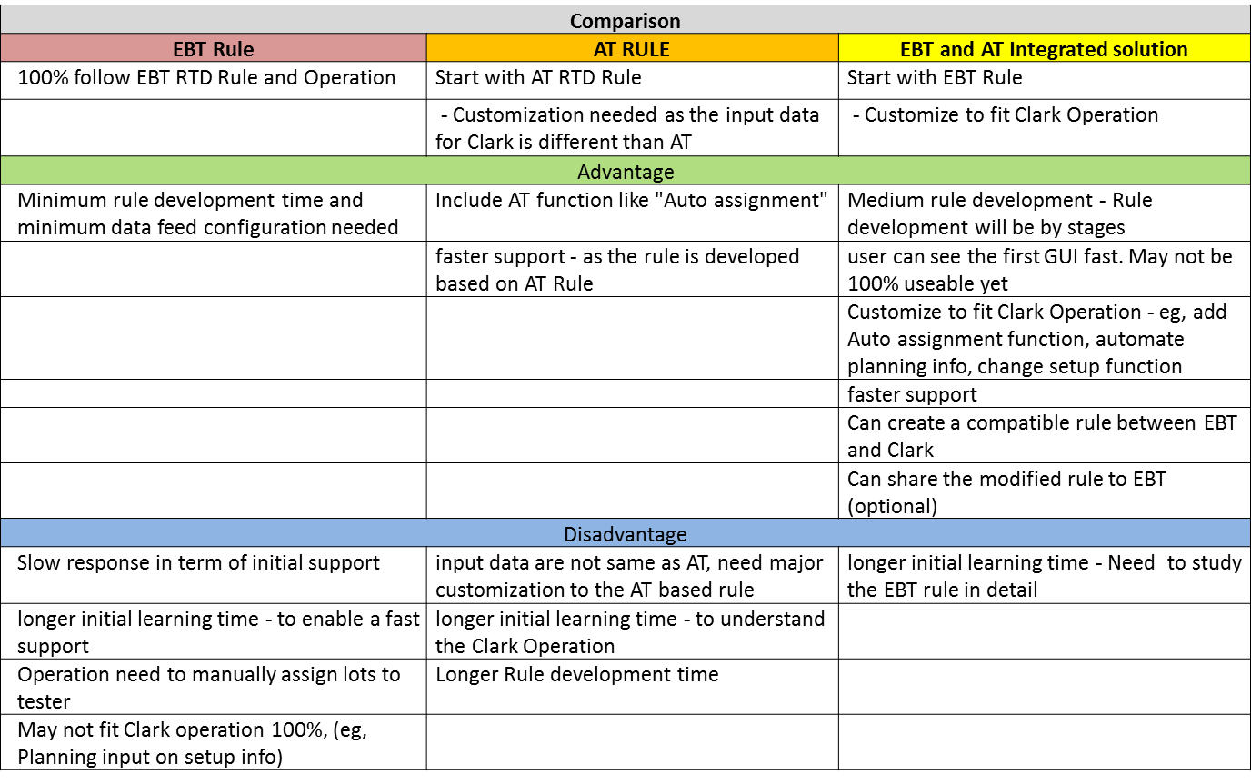
Figure 1: Comparison between different Rules

This option was shown to Clark Probe and ITS Management, the Team has agreed to select option 3 EBT and AT Integrated Solution. First Clark will Copy Exact RTD Rule from EBT/SCT and then enhance the rule with some AT RTD features, like Auto Dispatching.

3.3 Project Phases
A major obstacle in rolling out with EBT and AT Integrated Solution was the lack of knowledge concerning the EBT Operation and system. Keeping this in mind, the rule implementation was broken into three phases.

- Phase 1 – Copy Exact EBT operation and System to Clark Probe VLCT platform

- Phase 2 – Expend Clark Probe RTD to remaining platform (Eagle, Fusion, Iflex & J750)

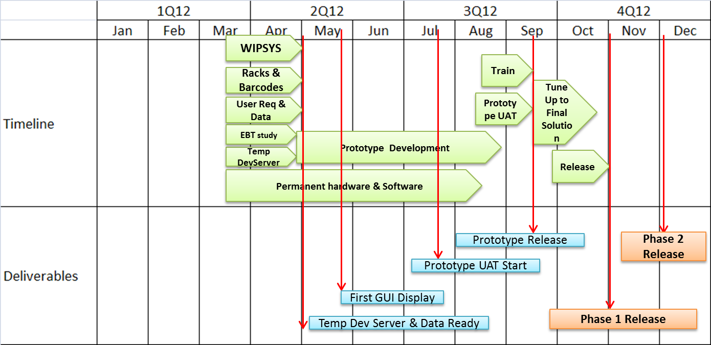
Figure 2 show the Project road map

The critical path on phase is to identify the gap in Operation and System between EBT and Clark. Some 35 RTD import files coming for various systems like Trackwork, Smsdw, Local application for planning demand and Testware are giving input to EBT RTD. Beside system Manufacturing Operation was reviewed and compared with Clark. Figure below show the new manufacturing process flow for Clark.

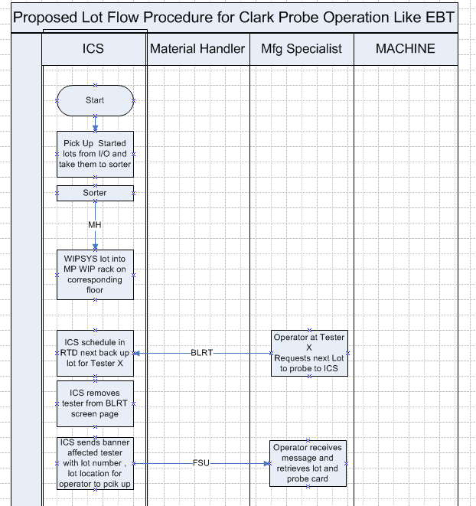
Figure 3: New SOP for Clark Probe

3.4 RTD Architecture
We have decided to design RTD Architecture to base on AT model. Primarily due to future expend, which will be expended to Clark TEST RTD. Our studies also show, that the AT architecture is far more reliable.

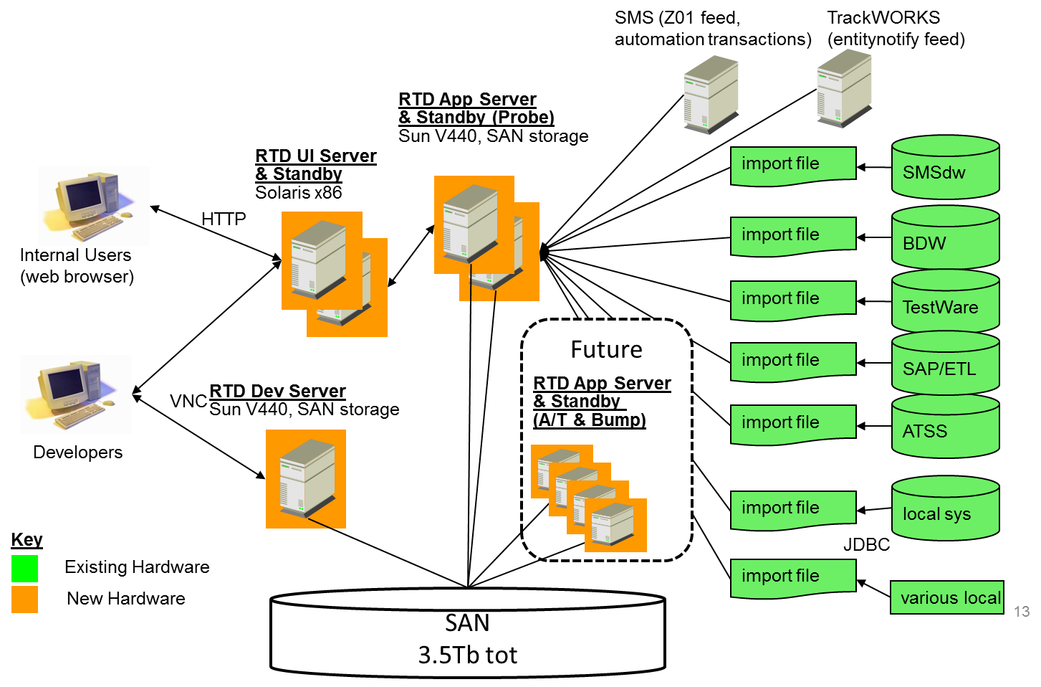
Figure 4: RTD Architecture

4.0 SOLUTION

We designed a strategy to use this opportunity to align all our Probe facilities to use the same solution. Then, we decided to start with base code from our EBT sister Probing facility in Dallas Texas. Although EBT RTD solution had been already successful, it was not as automated as Clark management expected it to be. Therefore, we decided that our strategy would be to copy base code from EBT facility into Clark facility and later enhance this solution by adding automated components we had deployed in our Test sites worldwide in order to reduce the human dependency for most of the dispatch (our target is 90% auto dispatch). Later on these enhancements will not only roll back to EBT but move on to our next Probe facility.

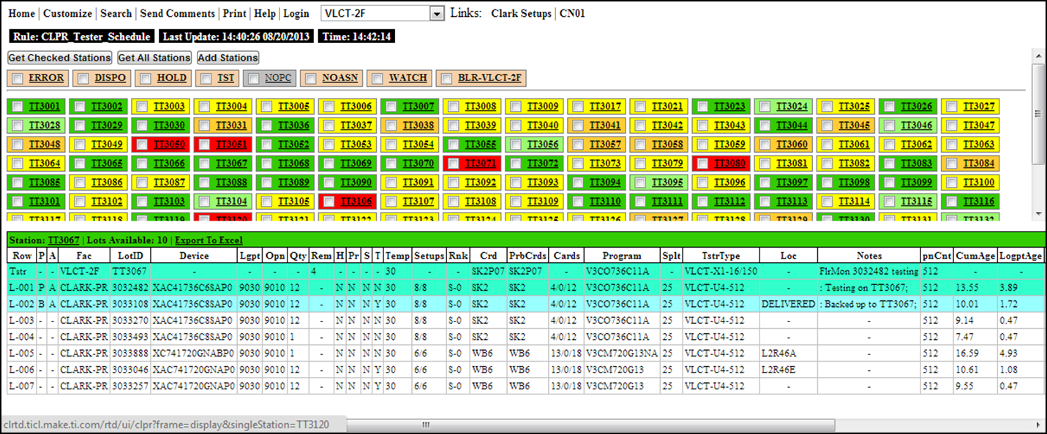
Figure5: RTD-GUI

As seen in figure 6 our development took 2nd and 3rd quarter of 2012 before we could release to production. Critical path during this period of time before releasing to production is a) developing and integration of the new dispatching system, b) acquire the hardware infrastructure to run the computer system, c) logistics pre-requisites such as WIP racks barcode labeling, and d) one of the most important is to perform a process flow analysis before and after to simplify, improve, and align the standard operating procedures followed by the personnel.

The nature of implementing this type of dispatcher is such that even after releasing to production unforeseen situations require adjustment. These unforeseen situations are product of the complexity of semiconductor environment and they are most likely to surface on daily operation and not in the test phase of the deployment cycle. Therefore as seen in figure 5 we spent 4th quarter 2012 fine tuning our solution and reinforcing personnel training.
5.0 Results
4.1 Project Result
A seen in figure 6 after releasing the system to production and making the proper adjustments on data and procedures we started to really utilize the system by end of 2012. From the graph below we can see the benefit of using the dispatcher. In first quarter of 2013 we realized higher % Cycle Time Percent (%) Attainment average by about 10 points and Lower Variance of cycle time % attainment among the all the product types we deliver making our customers more evenly serviced and more material meeting target cycle times on delivery.
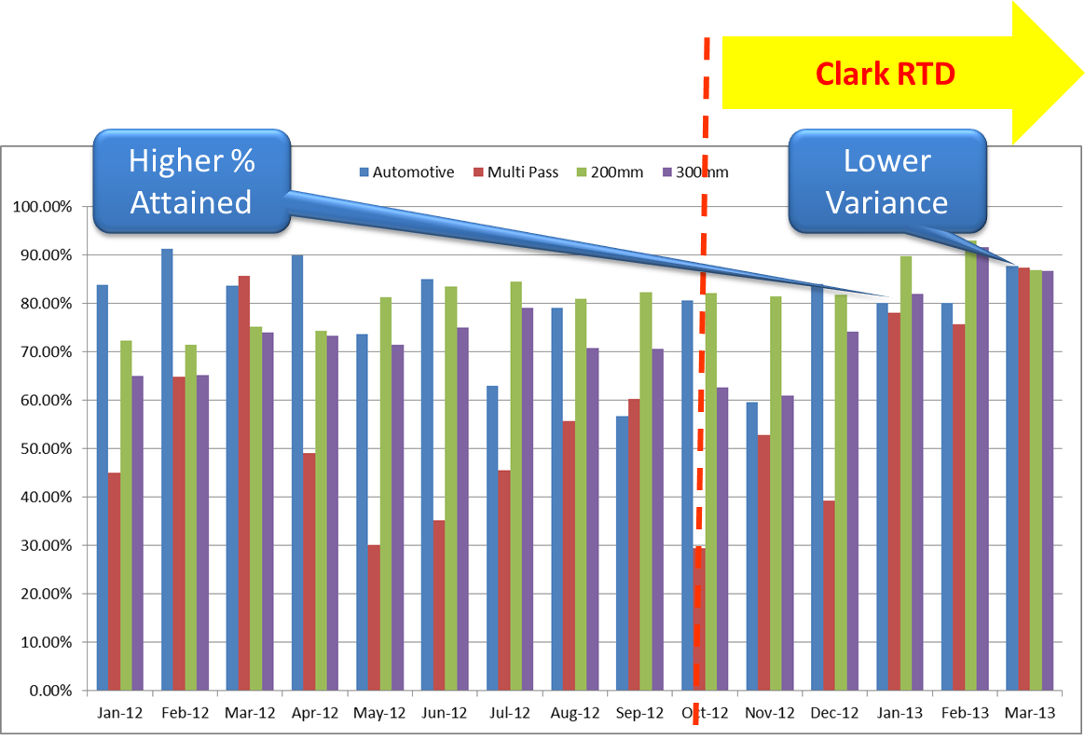
Figure 5. In the period of 1 quarter we realized significant improvement of cycle time % attainment and less variance in cycle time among product types being delivered.

4.2 Project Gain
Through this implementation, there is potential to save remove 3 Material handlers per shift.

Estimated Cost saving due to Material Handler:
No. of Material Handler = 3 per shift
No of Shift = 3
Cost of Material Handler = USD 1.16 per hour

Total Cost saving = No. of Material Handler x 8 Hours x No of Shift x Cost of Material Handler
= 3 x 8 x 3 x 1.16
= USD 83.52 per day
= USD 30,485 per year

6.0 Conclusion
As a conclusion, the RTD Implementation in Probe met the objective, which is improving manufacturing Cycle Time Attainment. The challenge in this project is to find most stable architectural design, integration and impact on automation operation in handling exceptional scenarios. Most of this challenge has been work out through inter-department teamwork including the RTD, IT-Local/Dallas, Manufacturing and Product Engineering teams.
7.0 Future Plan
The Implementation of this project has successfully identified and improves manufacturing efficiency. However, the current implementation is merely based on EBT Manual dispatching. Several weaknesses identified and reserved for future plan and improvement. Below are the moving forwards items to work on as continuous improvement to this project:
- To roll back automatic dispatching rule to SCT
- Implement Auto dispatching
- Implement RTD at Probe Wafer IO area
8.0 Acknowledgment
Authors would like to extend their gratitude to all individuals in Texas Instruments Management, Manufacturing Module, ACE, IT local/Dallas and Product Engineering Module for their continued support in this project.
9.0 Reference
- “Improving Test Program Sensitivity in Detecting Missing Wires and Shorts on Multi-Bonded pins”, 15th TIPI Technical Conference
- Test Multifunctional System, A Tool That Drives Productivity Improvement and Efficiency on Test Production Floor”, 17th TIPI Technical Conference
- “Real-Time Dispatching (RTD) for Multi-Chip Module” 16th TIM Technical Conference 2010, Selangor Malaysia.
- “Productivity Improvement at TITL Test Module through RTD Implementation” 17th TIM Technical Conference 2011, Selangor Malaysia.
- Tali Carmon-Freed, Ph.D, “Scheduling Semiconductor device Test Operation”, 1996 IEEE/CPMT International Electronics Manufacturing Technology Symposium.
10.0 About the Author
Thangappan Krisnamuthi joined TI Malaysia as a Senior System Engineer for IT ACE-TIM early August 2008 and he holds responsibility to provide real time dispatching solutions for TI ATs' sites (CLARK, TIM, TITL and TIPI). He was awarded Bachelor of Electrical (Honors) from Multimedia University. He has more than 11 years working experience in the field of APF/RTD. Prior to joining TI he was attached to Chartered Semiconductor Manufacturing Ltd as Manufacturing Systems lead and Silterra (M) Sdn. Bhd. as Senior IE Engineer.

